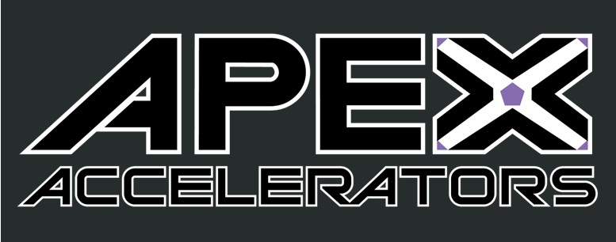
GACO’s

Quarterly Newsletter August 2023

In This Issue
- DLA Aviation – Vendor Information Hub
- SBA 8(a) Applications on Hold
- Quick Highlights
- Agency Spotlight

The GACO, APEX Accelerator serves the Pennsylvania counties of Allegheny, Beaver, Butler, Greene and Washington

GovCon News
DLA Aviation – Vendor Information Hub

On July 12th, DLA Aviation launched a new webpage. The vendor information hub provides vendors resources on how to work with DLA Aviation, how to access DLA acquisition tools and provides a one-stop-shop for vendors. More information can be found at Vendor Information Hub (dla.mil). Join DLA for an information session about the new hub on August 15th at 10:00 a.m. Register at Vendor Information HUB (New) > Calendar (dla.mil).

SBA 8(a) Applications on Hold

U.S. District Judge ruled the SBA can’t automatically assume a small business is socially and economically disadvantaged based on the owner’s race. The SBA has placed a temporary hold on new 8(a) applications until it can evaluate the ruling. See article below for more details.

SBA pauses applications for 8(a) business program | FedScoop
2
Contact Us
GACO, APEX Accelerator
250 University Ave
Box 20
California, PA 15419 724‐938‐5881
gacoapexaccelerator@pennwest.edu
www.calu.edu/gaco
Quick Highlights
- United States Special Operations Command (USSOCOM) Virtual Small Business Roundtable, August 24th , 2:00 p.m., Small Business Roundtable Invitation Request (socom.mil)
- DOL to Update Prevailing Wage – rates will be determined by 30% of workers rather than 50%, DOL to update prevailing wage laws | Construction Dive

- The National HUBZone Conference, August 22nd – 23rd – Leesburg, VA, HUBZone Contractors National Council - 2023 National HUBZone Conference (hubzonecouncil.org)

- DLA Link Newsletter – Issue 29, Notice Display (dla.mil)

- SAVE the DATE – GACO’s 34th Procurement Opportunities Fair – October 25th – Monroeville Convention Center, www.calu.edu/gaco.

Agency Spotlight – SBA Celebrates 70th Anniversary

The Small Business Administration (SBA) was founded in 1953 by President Eisenhower with the signing of the Small Business Act. Since then, the SBA has advocated for the interests of our nation’s small businesses. See the most recent SBA scorecard highlighting federal spend accomplishments.

Small businesses’ share of federal contracting dollars reaches ‘all time high,’ SBA says - Government Executive (govexec.com)

